Project Description

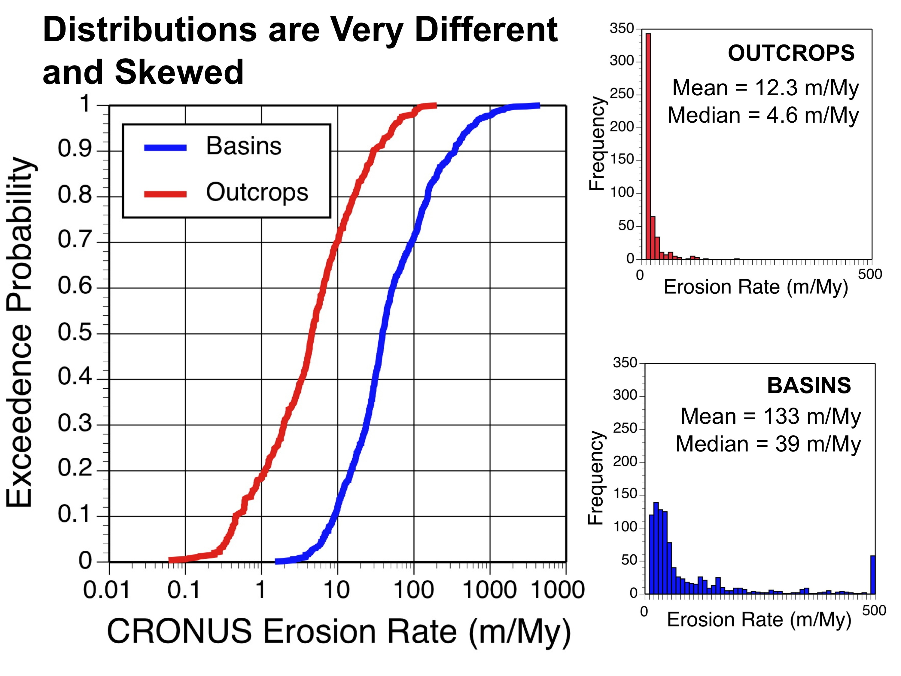
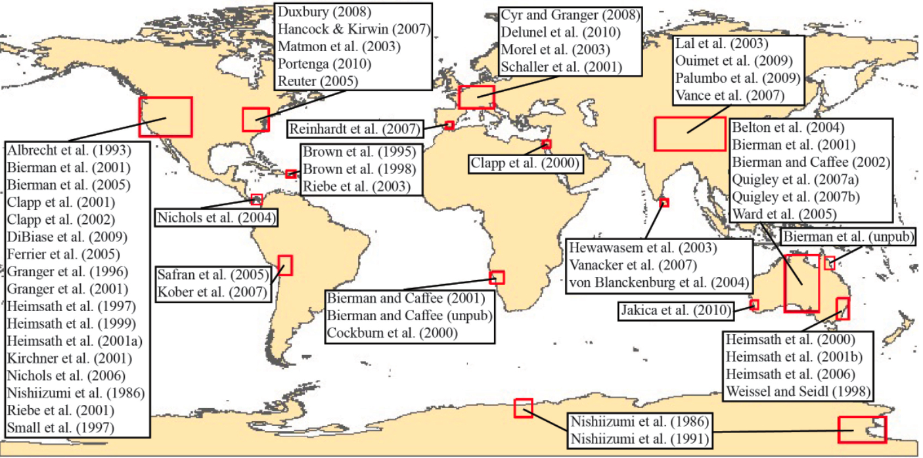
Fig 1. Compilation of extant bedrock and watershed ¹⁰Be erosion rate estimates shows large data gaps, skewed distributions, and offset between the erosion rate of bedrock outcrops and drainage basins.
1. Project objectives and their relationship to the FESD program goals
Our research explicitly addresses a first-order question at the frontier of Geoscience, a question that is today, unanswerable. How quickly do different parts of the world erode and how do changes over time and space in climate, land use, and tectonics affect erosion rates? With humans now the most active agent of planetary change – altering Earth’s surface and climate at an unprecedented pace (Hooke, 19XX; IPCC) – understanding how the thin mantle of soil and regolith covering our planet will respond to such changes is critical, especially when this soil feeds the Earth’s 7 billion inhabitants
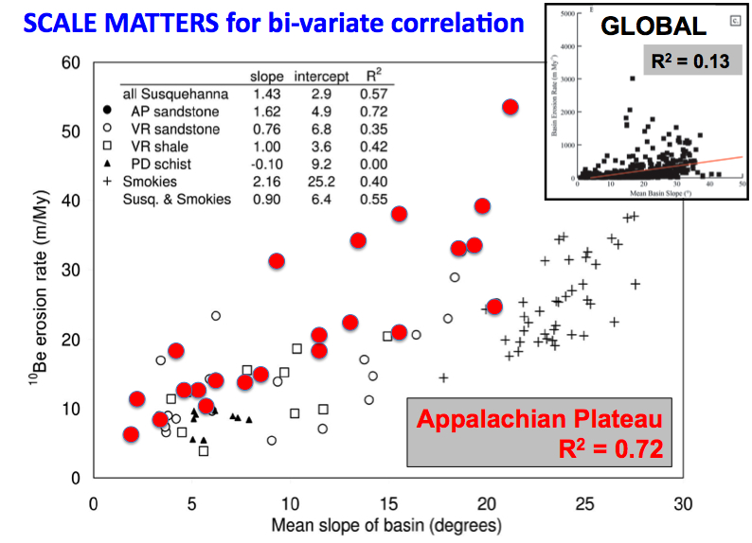
We are poised to understand, and thus predict in a changing world, the rate at which any drainage basin on the planet erodes - if only the global data set of measured erosion rates were less fragmentary and biased. Over the last several decades, development of cosmogenic and short-lived isotopic methods of estimating erosion rates (REFS), improved understanding of the linkages between deep Earth and surface processes (REFS), insight about climate change over time (REFS), and the advance of complex systems modeling capabilities (REFS) have set the stage for realistic simulation of the interactions between tectonics, climate, and landscape evolution over varying time and spatial scales. Millennial-scale erosion rate data are the key to such simulation and today we now know how to gather them rapidly and accurately using measurement of ¹⁰Be produced by cosmic rays (REFS). Short-lived nuclides provide decadal to century scale data (REF) wheras sediment yields reflect a more immediate, human timescale of years to decades (REFS).
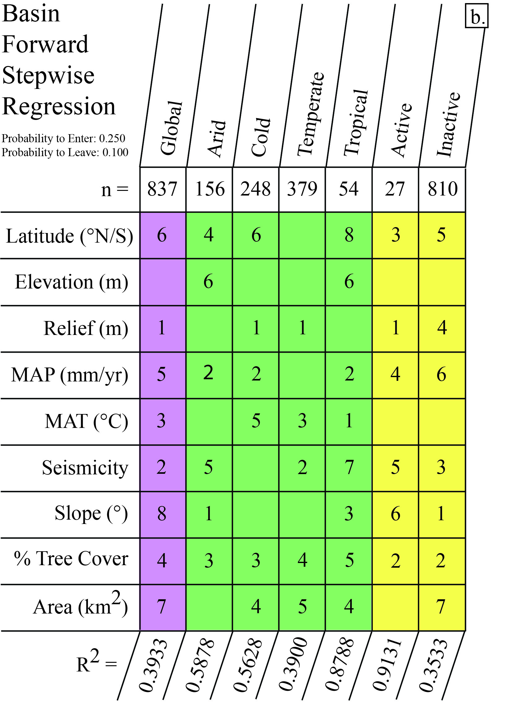
Meta analysis of published cosmogenic erosion rates points out massive data gaps – 100s of measurements have been made in North America but only a handful in Africa and South America (Fig. 1). Only a few data can be used to infer how erosion rates change over time (Schaller, Granger REFS). Simple bi-variate regression models indicate limited global correlation between landscape-scale parameters such as slope and erosion rate but illustrate dramatically the scale-dependence of such relationships (Fig. 2). Multiple regression analysis does better, explaining reasonable amounts of variance (Fig. 3), but large amounts of co-variance and non-linear relationships between climate, tectonics, and landscape-scale variables suggest that more complex analytical techniques will generate far better erosion rate predictions.
Fig. 2. Regression of erosion rate vs slope for Susquehanna River data shows high R² for basins on one lithology in a restricted area. Global regression shows much less predictive power.

Study of Earth’s erosion engine, such as we propose, is critical to a multi-scale understanding of the interplay between various sub-systems of the Earth and is the ideal vehicle by which train scientists and engineers to work together addressing key problems in Earth-system dynamics. The synergy of isotope geochemistry, tectonics, complex systems modeling, and expertise in graduate and undergraduate science education will develop the next generation of practitioners while completing a project that provides knowledge critical for understanding the resilience of the Earth and its soil system to massive human impact.
Fig. 2. Multiple regression of global basin-scale erosion has higher predictive capability (R²) than bi-variate relationships.

2. Work plan to accomplish project objectives.
This project will map erosion rates over time and around the globe by measuring in situ produced cosmogenic ¹⁰Be and the short-lived nuclides (¹³⁷Cs and ²¹⁰Pb) in river sand (Bierman and Steig, 1996; Brown et al., 1995; Granger et al., 1996). Our multidisciplinary team will use complex systems analysis to infer the feedbacks and interconnections between erosion rates and climatic and tectonic forcing; this analysis will catalyze the creation of predictive models across a wide range of spatial scales. Cosmogenic ¹⁰Be (and as needed ²⁶Al) will be extracted in the new, efficient UVM clean labs and analyzed on the Livermore AMS. Short-lived nuclides will be measured at Skidmore on existing and newly acquired counters.

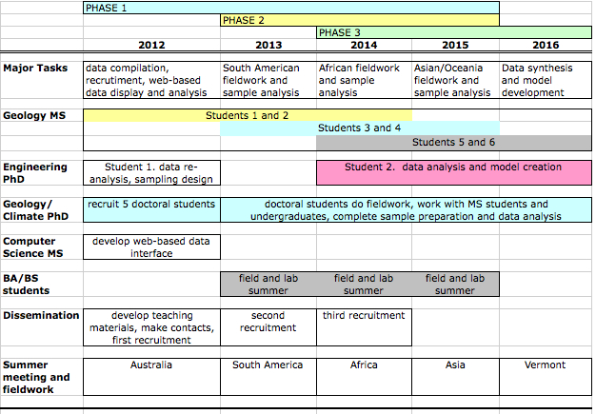 | Fig. 4. Project timeline showing phases, major tasks, timing of student recruitment and field/summer meeting locations.
Our approach to this project is phased (Fig. 4). Phase 1 is low risk and involves analysis of existing data, experimental design to develop statistically “smart” sampling plans, and collection and analysis of samples (for ¹⁰Be, ²¹⁰Pb, ¹³⁷Cs) to determine rates of erosion worldwide. Phase 2 is higher risk, with focused studies aimed at better understanding how rates of erosion change over time using ¹⁰Be and if needed, ²⁶Al. Phase 3 develops complex systems models useful for predicting rates of erosion at watershed scales across the surface of our planet.

Phase 1 (1/2012-12/2015): Faculty, working in concert with graduate students in Computer Science, Engineering, and Geology will complete the compilation of existing short and long-lived isotope data relevant to estimating basin-scale erosion rates and test a variety of predictive models to explain the data. This work will form the basis of the web-based Community Data Display and Analysis system (see section 7.b). We will use the structure of extant data to design optimized sampling plans for filling spatial, climatic, tectonic, and lithologic gaps in the global dataset. During Phase 1, we will develop a 4-day short course for training students in the program; the course will be offered during each annual meeting and will be open, without charge, to scientists from the four continents we visit. The course material will be modified from use during undergraduate recruiting visits. Limited sampling will begin in year one (Australia, faculty and PhD only); full sample campaigns will occur during years 2, 3 and 4 involving teams of faculty, graduate, and undergraduate students. Sample preparation and analysis will be done by students at UVM, Skidmore, and Livermore.

Phase 2 (1/2013-12/2015): The doctoral students will work in the field to identify specific field sites where erosion rates can be estimated over different time frames. These are likely to include sequences of river terraces, cave deposits, and previously collected marine cores. We will attempt to make such paleo-erosion estimates on different continents, in different climate zones, and over different integration times including the on-set of glaciation (~2 My), glacial-interglacial cycles, and the switch in glacial cyclicity at 700 ky.

Phase 3 (1/2014-12/2016): New data will allow doctoral students, in concert with project faculty, to develop sophisticated explanatory and predictive models, the output of which will be basin-scale erosion rates as a function of lithology, climate, and tectonic setting. Such models will likely be regional, as existing data suggest relationships are less robust at the global scale (Fig. 2). We will use robust complex systems tools, non-parametric statistical methods, designed for spatial (and temporal) parameter estimation. Such methods are critical because erosion rate drivers are autocorrelated, non-normally distributed, and mixtures of categorical, continuous and discrete-valued variables that cannot be analyzed using the traditional geostatistical or categorical data analysis techniques. The entire dataset, including the compilation of other published data, will be served up on the project website with live-time data plotting and analysis routines. Models will be compared to global compilations of current sediment yield data and models based upon these data (Milliman, svetski, Summerfield).

3. Project Management Plan
This project is a collaborative venture between three institutions and four PIs all of whom have worked together extensively, co-advising graduate students in different combinations over the past 10 years. Because we have well-established professional relationships, project management will be dominantly collaborative with face-to-face PI meetings every 6 months and scheduled monthly conference calls between the investigators. Bierman will oversee the entire project and its budget as well as cosmogenic isotope sample preparation, measurement, and interpretation by graduate students. He will manage the part-time project administrator and lead the interaction with foreign collaborators. Co-PI Kirby will lead the portion of the project related to solid Earth/surface interactions. Co-PI Rizzo will direct data analysis and modeling and Co-PI Nichols will mentor the Postdoctoral associate, oversee undergraduate recruiting, and direct short-lived radionuclide measurements and interpretation. Graduate student admission will be coordinated between Vermont and Penn State with admission files read and discussed by all PIs. We anticipate that graduate students will have one lead advisor at their home institution but will be co-advised by the other project faculty. All students and faculty involved with the project will gather every summer, on a different continent, for the annual project conference.

4. Why the proposed research is poised for a major advance
Thirty years of cosmogenic and short-lived radionuclide measurements have clearly shown the ability of these systems to measure rates of erosion on both short (decadal) and longer (millennial) time scales [REFS]; yet, the extant data are hardly global in their coverage (Fig. 1). Today, sample preparation and analytical techniques make the processing of hundreds of samples a year practical. Paleoclimate and tectonic studies now provide explicit boundary conditions for most of the world over the last million years. Complex systems analysis has advanced so that realistic models can be crafted to explain multiple co-varying influences. Together, these advances put within our reach a global predictive model of erosion rates over space and time. This is a major advance in our understanding of Earth as a system.

5. Why the research requires a team-based interdisciplinary approach
Predicting the spatial and temporal distribution of erosion on Earth’s dynamic surface where climate, tectonic forcing, and material properties change over time and space is a complex, multi-dimensional problem; thus, bringing together a collaborative, multi-disciplinary team is critical to making transformative advances in our understanding. Each team member brings overlapping but specific and necessary expertise to the project: PI Bierman: application of cosmogenic nuclides and human/landscape interaction; Co-I Kirby: linkage between solid earth and surface processes; Co-I Rizzo: geostatistics and complex system modeling expertise; Co-I Nichols: short-lived nuclides, diverse undergraduate recruitment

6. Why the research is potentially transformative
In the absence of site-specific data, geoscientists are unable to estimate background rates of erosion to better than an order of magnitude. Effects of changing climate or tectonic forcing on rates of erosion are even more poorly constrained. Yet, the spatial and temporal distribution of erosion is a fundamental for understanding Earth as a system especially in face of rapidly changing climate and a burgeoning population who depend on soil (a product of erosion) for food production. A broad range of disciplines including Engineering, Soil Science, Petroleum Geology, and basin analysis require good estimates of erosion; yet none are available. Creating a reliable, predictive model for erosion rates as a function of climate, tectonics, and rock type will transform the way in which a large number of STEM disciplines understand Earth as a system.

7. Broader impact activities
We have developed a coherent and wide-ranging set of activates to ensure that a variety of broader impacts result from this project.
a. Recruiting and retaining under-represented groups – Diversifying graduate and faculty ranks in the Earth Sciences and Engineering is not easy; thus, we have designed an active recruiting program that will be co-led by an experienced undergraduate educator (Nichols) and a post-doctoral Associate. Led by the post-doc, project participants will travel to a variety of undergraduate schools, including those with large under-represented populations, and recruit students during 2-day, hands-on short courses about Earth’s erosion engine, that we will offer free of charge. Undergraduates we recruit will be paired with graduate students for fieldwork and before fieldwork, will travel to UVM/Penn for planning meetings and to meet the project faculty. All undergraduates will participate in foreign meetings and fieldwork – our hope is to recruit the best undergraduates as graduate students, this diversifying the entire program.
b. Community Data Display and Analysis system – Coincident with the start of the project, graduate students in Computer Science and Engineering will use their knowledge of database systems, statistical analysis, and graphical display to and develop, deploy, and refine a web-based data hosting, display, and analysis system. Initially, the system will host all available cosmogenic and short-term nuclide data collected from bedrock outcrops and fluvial sediments (we have already done this compilation). All new project data will be added “real time” to the database. The system will be designed to accept data easily from other investigators; the goal here is to create a global repository of data easily accessed by anyone 24/7.
c. Short course development and dissemination – During the first 6 months of the project, all of the PIs and the post-doc will work individually and together to develop educational modules and related teaching materials (hand-on activities) at two levels – one for undergraduate education, the other for training professionals including graduate students and faculty both within and outside of the program. These materials will be used during the summer trainings, the recruiting visits to schools, and toward the end of the project, at GSA and AGU short courses disseminating our approach and results.
d. International exchanges – International partners are integral part to this project. The entire project team will travel to Australia, Africa, South America, and Asia to present our findings to scientists on these continents and to work in the field with local students and faculty. We will host foreign graduate students in our labs for weeks to months to generate and interpret data further diversifying the project team – Australia and South American already have funding schemes in place for such student travel support.
e. Student training – The integration of three very different educational institutions, international collaboration, the inclusion of many different STEM disciplines including geochemistry, complex systems modeling, solid and surface Earth geology, and the nature of our approach will provide a uniquely stimulating environment for the 21 undergraduates and 11 graduate students supported by this project.
8. List a of collaborators and their role in the project
Name | Affiliation | Role
Dylan Rood | Livermore National Laboratory | AMS measurements and data reduction
Nelson Fernandes | Federal Univ. of Brazil | Guide South American Fieldwork
Antonio Corrêa |  | Guide South American Fieldwork
Gabriella Schneider | Direction, Namibian Geol. Survey | Guide African fieldwork
Dave Roberts | S. African Council for Geosciences | Guide African fieldwork
????? | ?????? | Asia? KIRBY
David Fink | ANSTO | Guide Australian fieldwork
Paul Hesse | Macquarie University | Guide Australian fieldwork

